**APPLICATION FLOW**

**FLOWS:**

1. Home Page - /

Display the home page to everyone, whether they are logged in or not.

There is a part that shows the logged-in user; if the user is not logged in, then it shows the PLEASE LOG IN message.

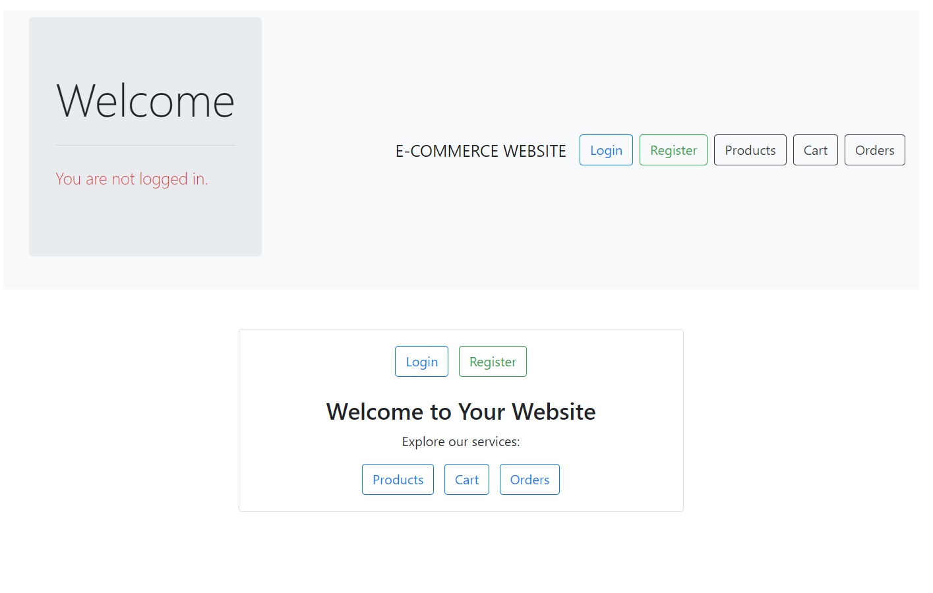

1. Login page: /login

Displaying a login page to users who login to the website

If the user does not have an account, they are given the option to register by clicking the register button below the login button.

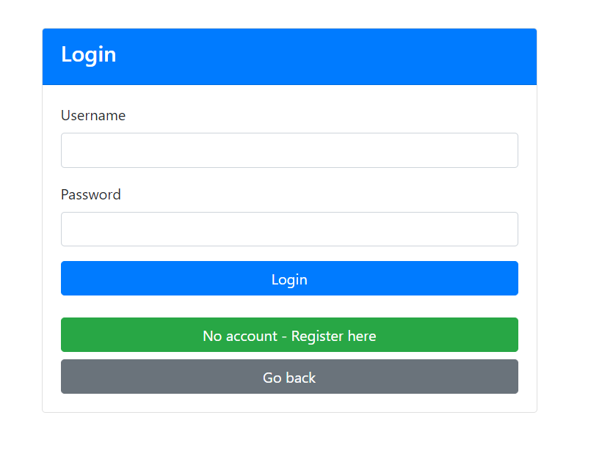

1. Register page: /register

Displaying the register page, if the user already has an account, gives the option to login with the above go to login button, which forwards and displays the login page.

Accepts username, password, and email.

If the username is unique, register the user and redirect them to the login page.

If the username already exists, display an error message on the registration page.

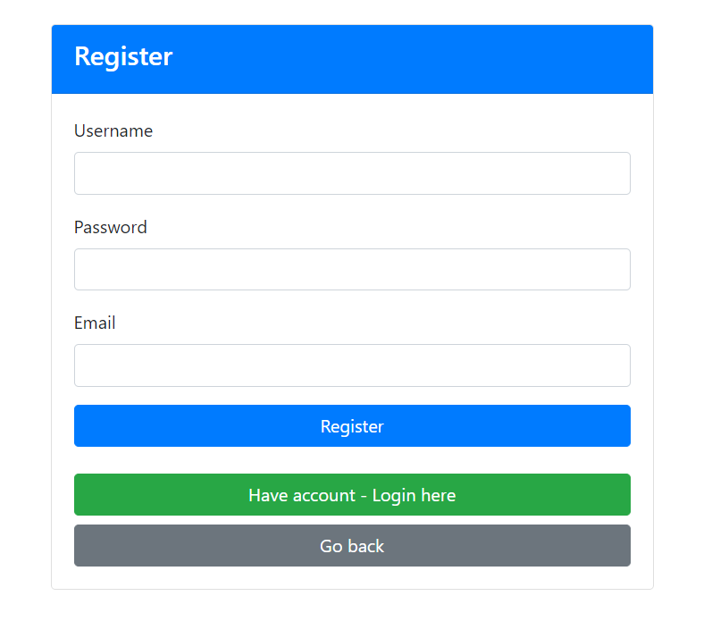

1. View Products (/products): A secured user should be logged in.

Display a list of products.

Each product has options to edit or delete.

If the user is not logged in, it redirects to the login page.

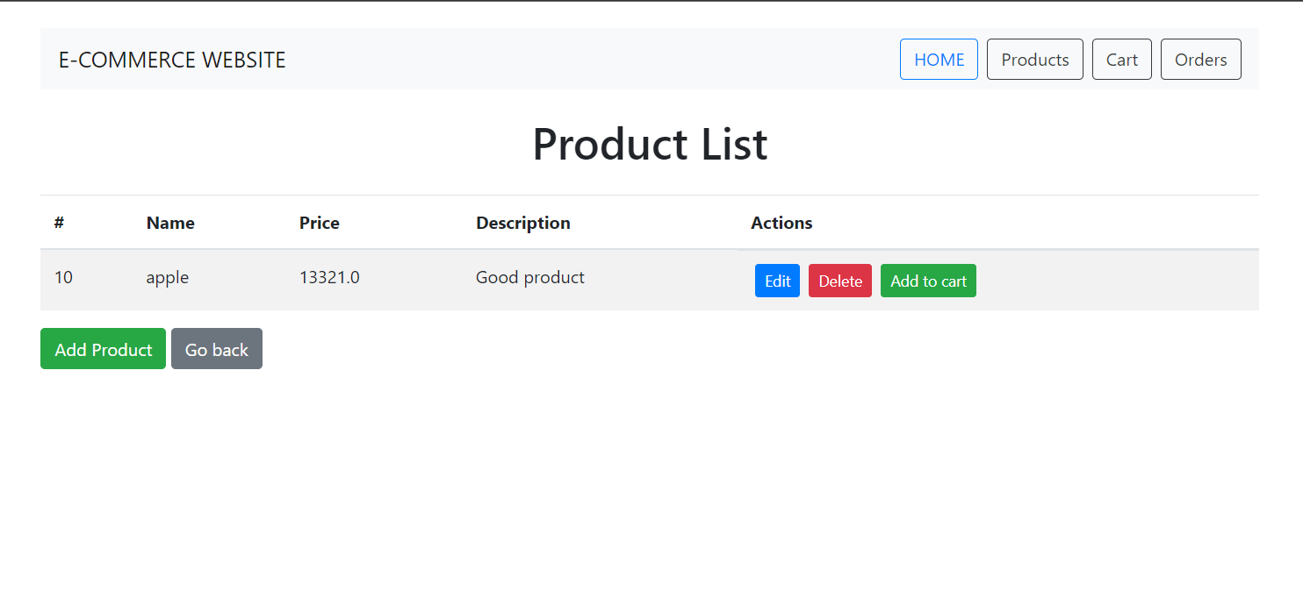

1. Add Product Page (/products/add):

Display the page to add a new product.

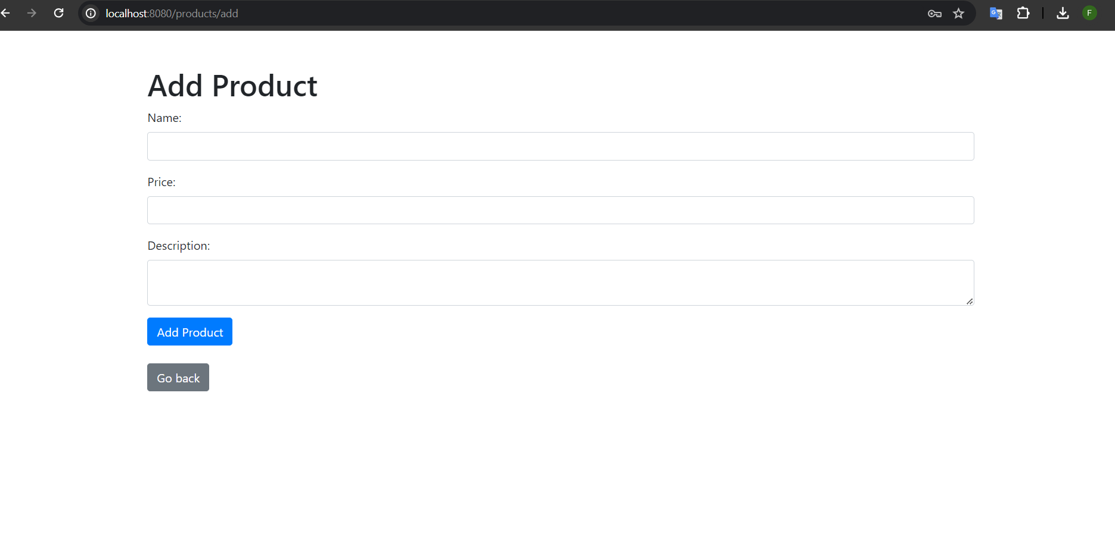

1. Add Product (/products/add) secured user should be logged in:

Accepts product name, price, and description.

Adds the product to the database and redirects to the product list.

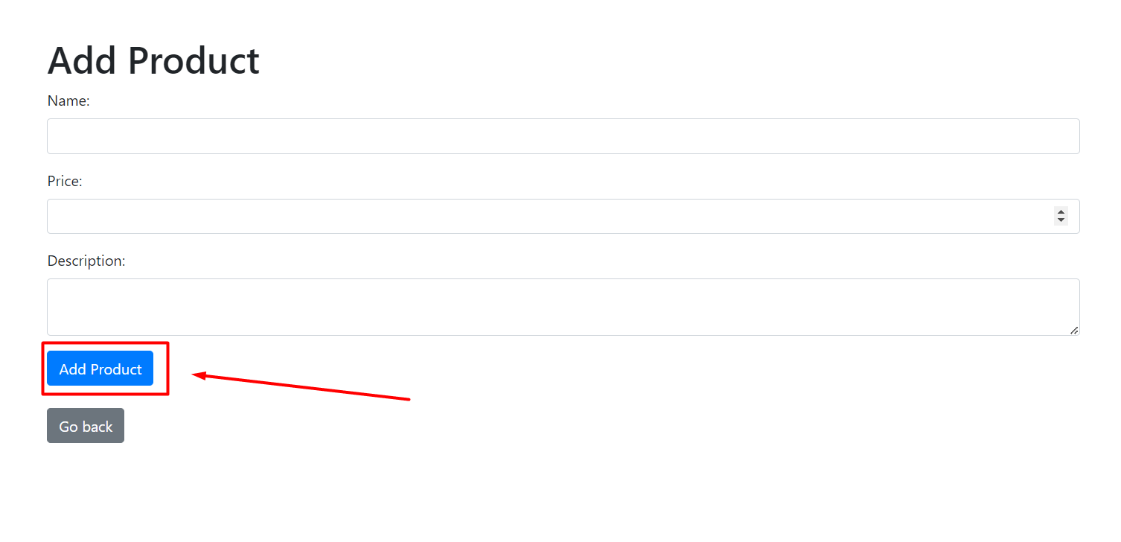

1. Delete Product (/products/delete/{productId}):

Deletes the specified product and redirects to the product list.

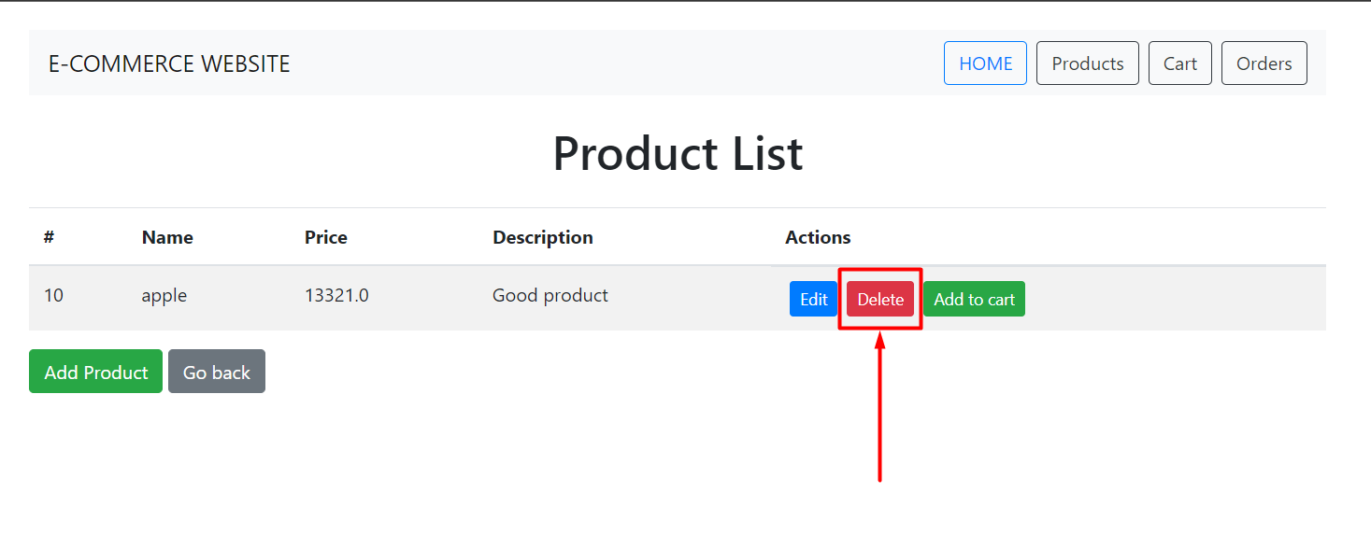

1. Edit Product Page (/products/edit/{productId}):

Display the page to edit the selected product.

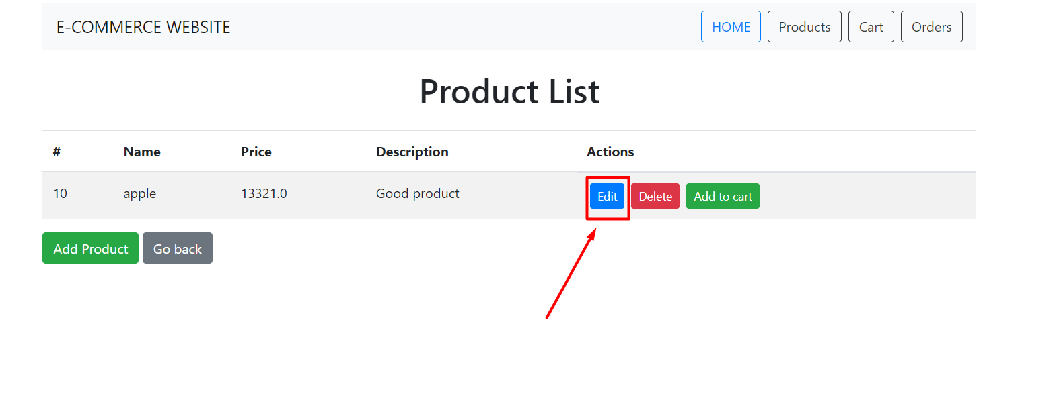

1. Edit Product (/products/edit/{productId}):

Accepts modified product details.

It updates the product in the database and redirects to the product list.

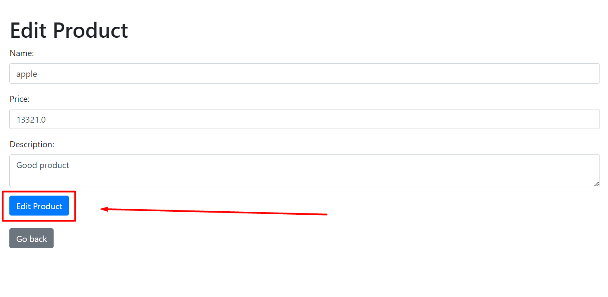

1. View Cart (/cart):

Display the items in the cart.

Allows removing items from the cart.

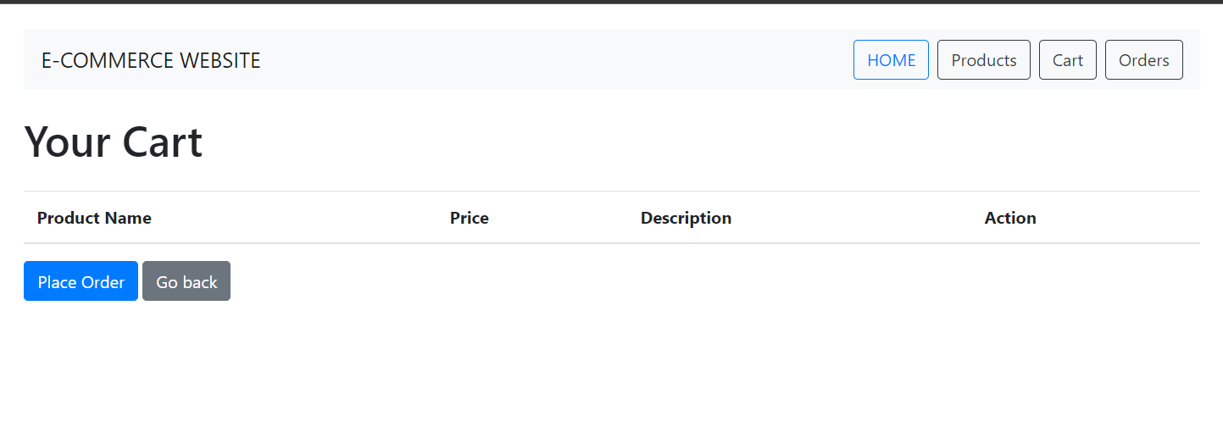

1. Add to Cart (/products/add/cart/{productId}):

Adds the selected product to the cart and redirects to the cart page.

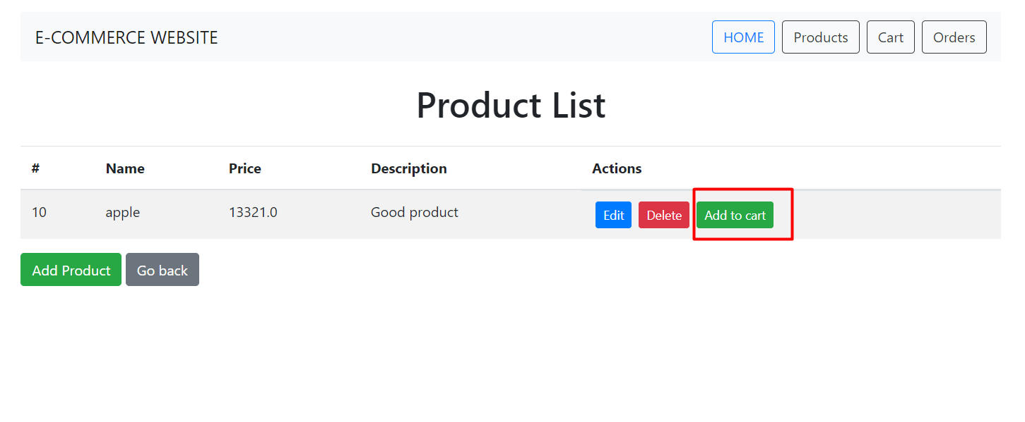

1. Remove from Cart (/products/remove/cart/{index}):

Removes the specified item from the cart and redirects to the cart page.

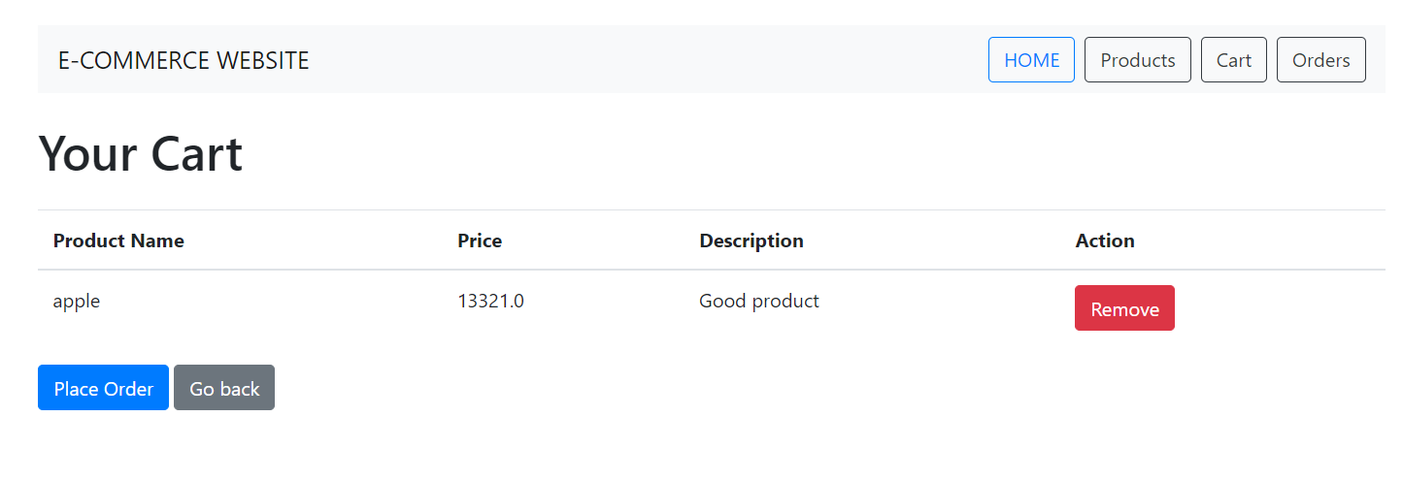

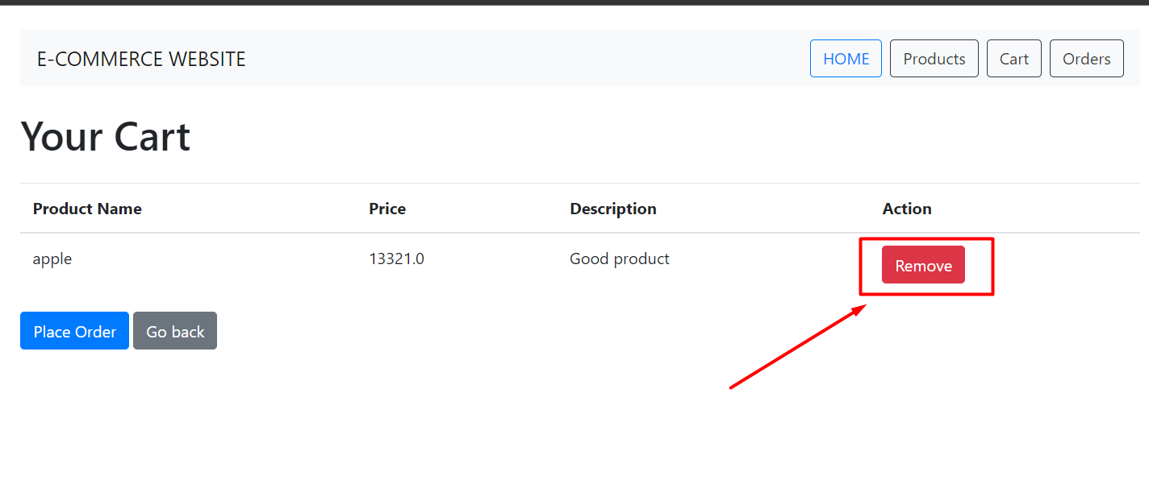

1. Place Order (/orders):

Places an order using the items in the cart.

Clears the cart after placing the order.

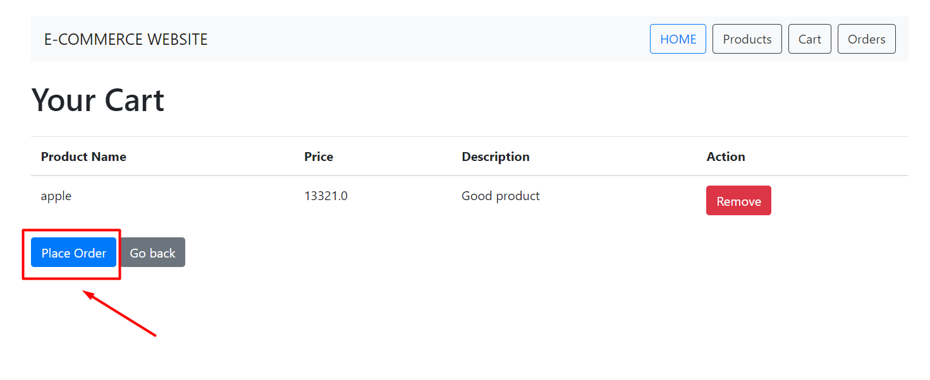

1. View Orders (/orders):

Displays a list of orders placed by the logged-in user.

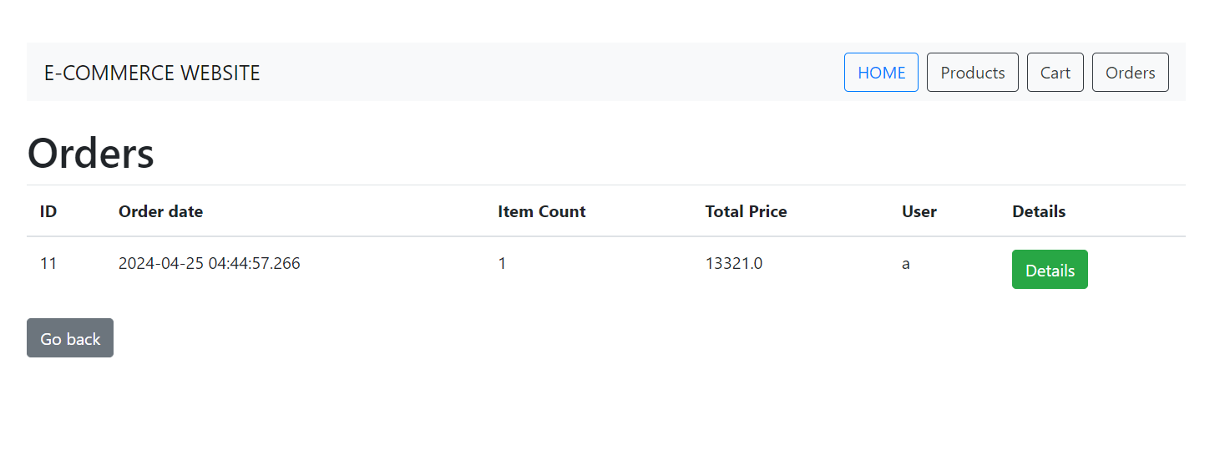

1. Order Details (/order/details/{orderId}):

Displays details of a specific order, such as order items, total price, etc.

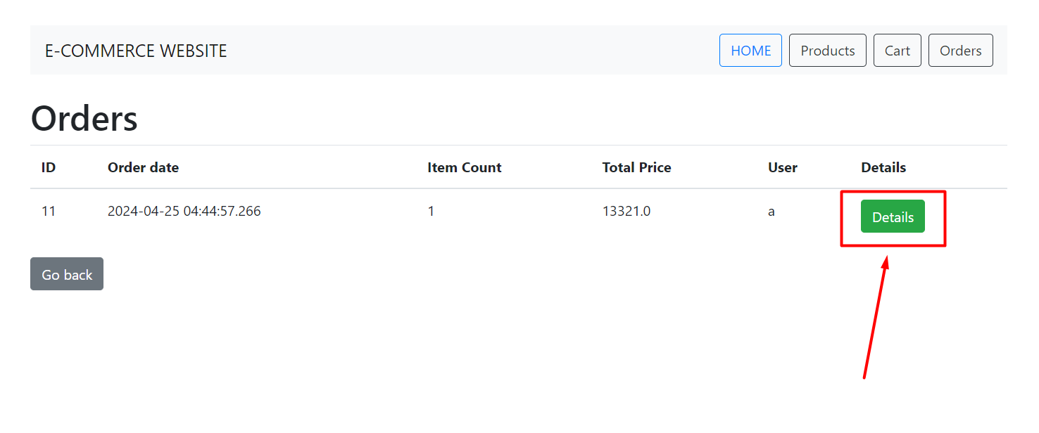

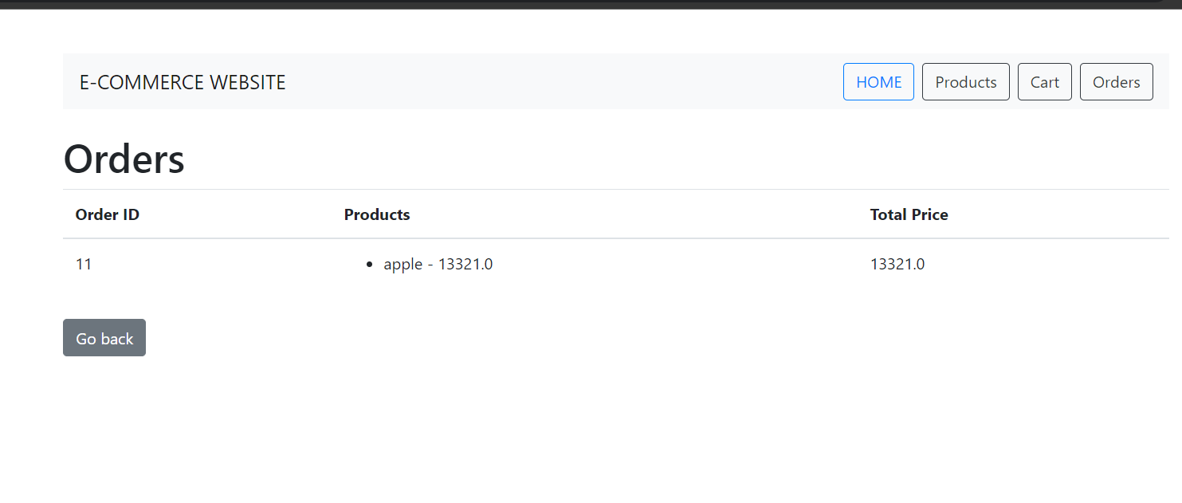

1. Logout (/logout):

Invalidates the session and redirects to the login page.

